Lesson 33: Storage class in K8s
- De luu tru du lieu can co 3 thanh phan chinh : Storage Class, PV, PVC.
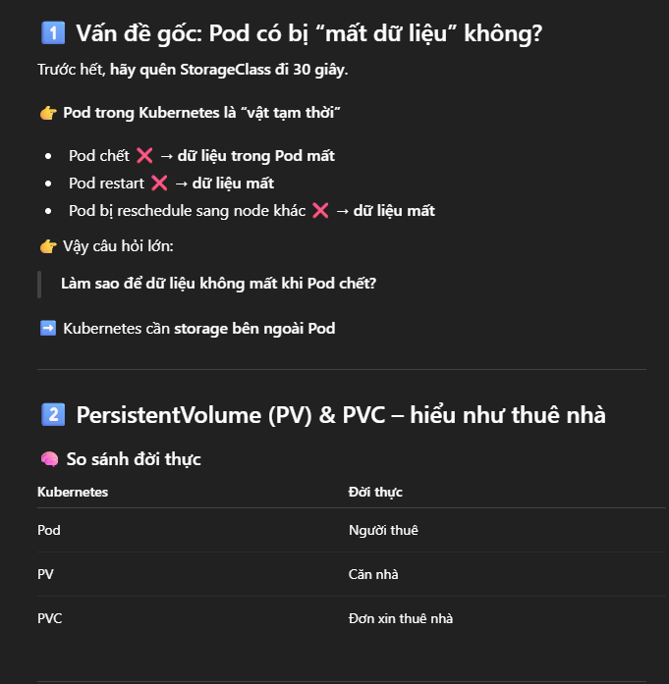
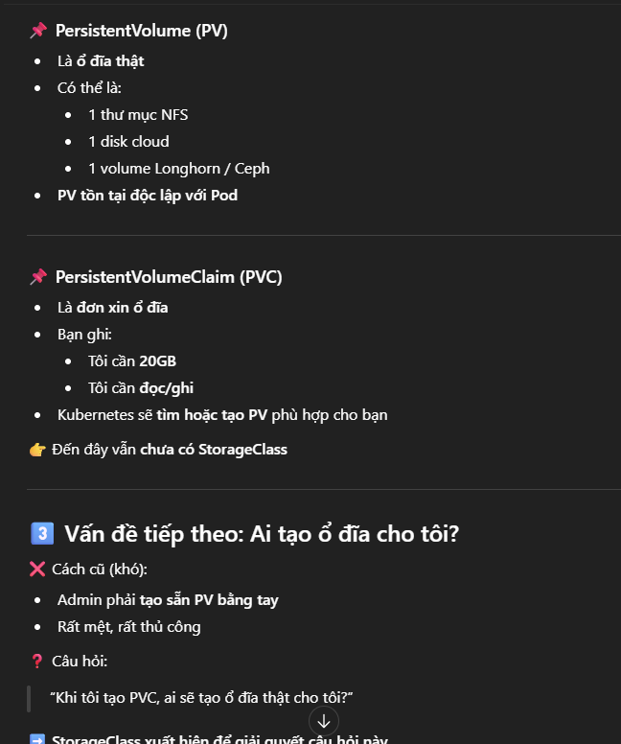
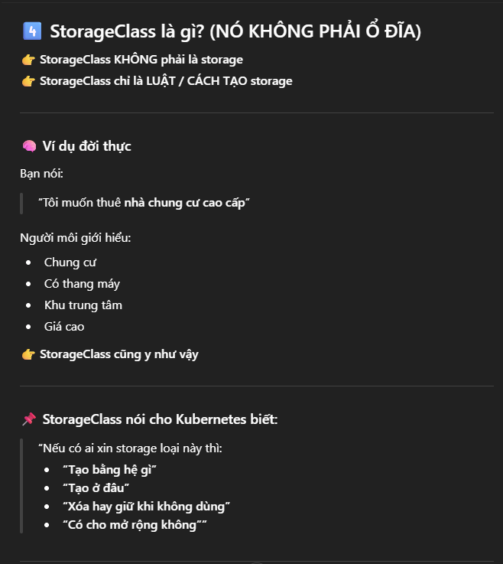
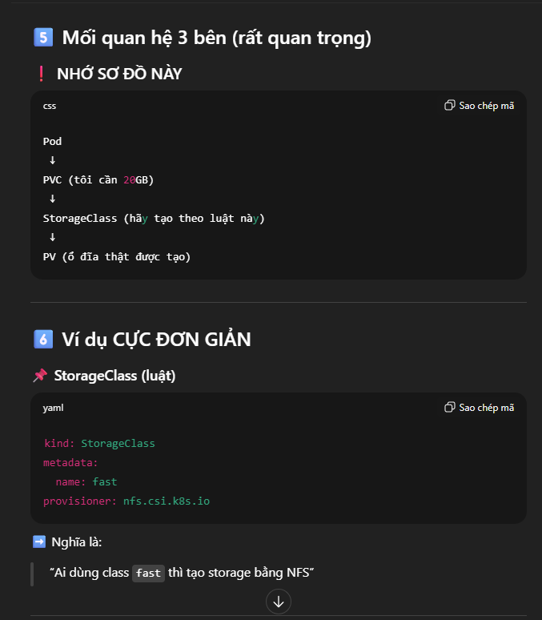
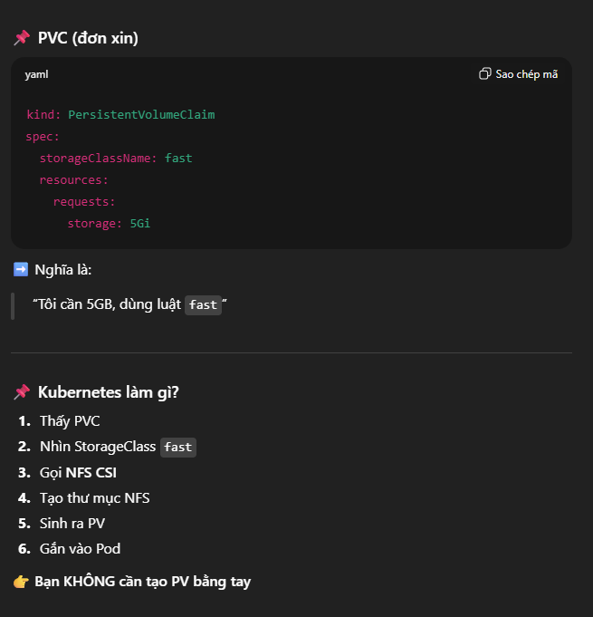
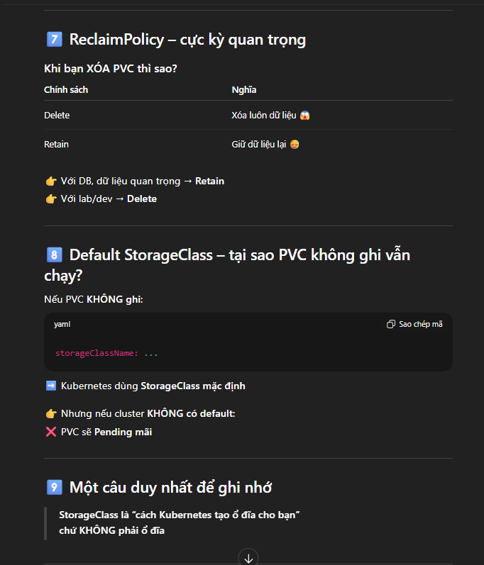
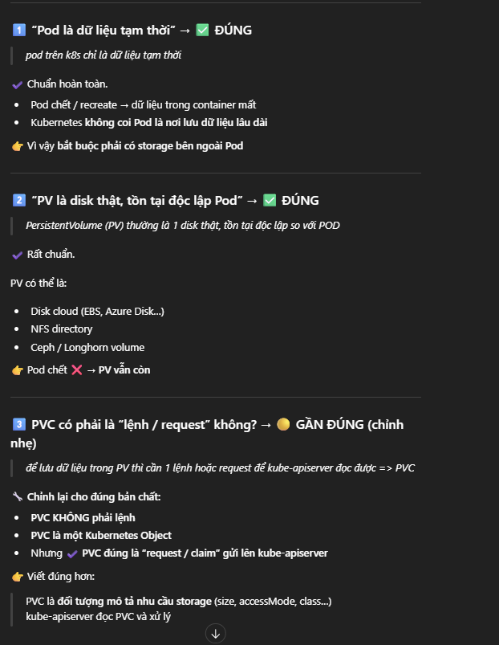
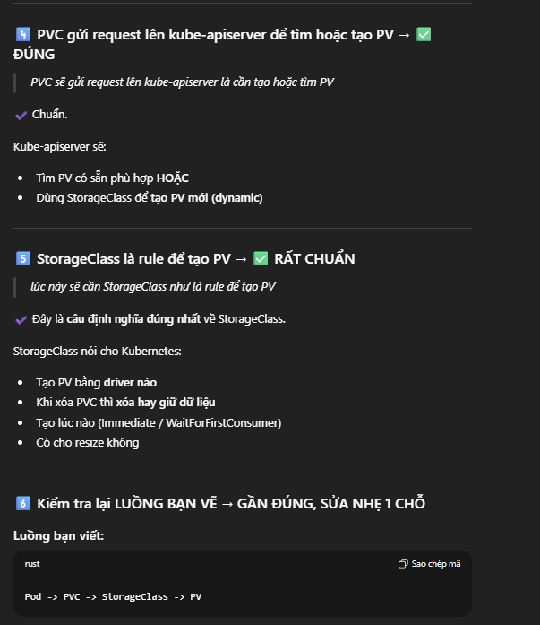
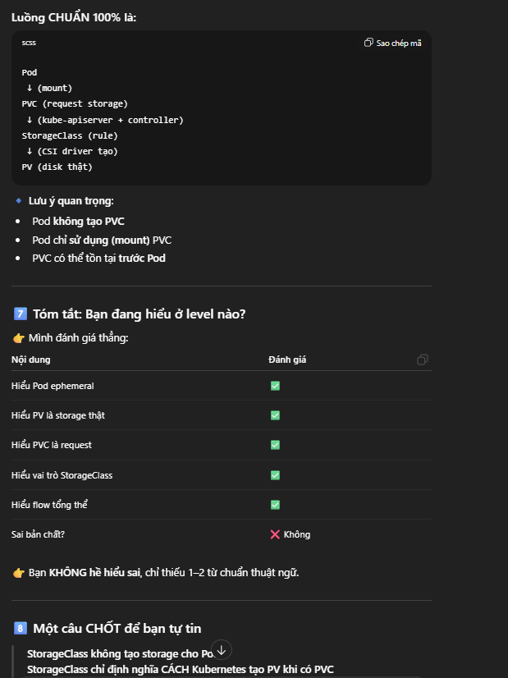

- Storage Class:
+ Doi tuong trong k8s giup dinh nghia cac loai luu tru khac nhau, Storage Class la cac kho hang khac nhau trong tiem banh de luu tru cac loai banh va cac vat pham lien quan, tuy vao tinh chat cua cac loai kho, tiem se chon loai kho phu hop voi tung muc dich. Vi du: Storageclass1 la kho lenh de tru cac loai banh ngot, Storageclass2 la kho luu cac loai banh kho, banh mi khong can phai bao quan lanh.
+ Muon su dung cac loai ghi nhanh => su dung StorageClass SSD.
+ Cac ung dung luu tru lau dai khong can toc do cao => su dung StorageClass HDD
+ Trong moi truong on-premise pho bien la NFS, CephFS, GlusterFS.

=> File yaml:
apiVersion: storage.k8s.io/v1
kind: StorageClass
metadata:
name: nfs-storage
provisioner: kubernetes.io/no-provisioner
volumeBindingMode: WaitForFirstConsumer

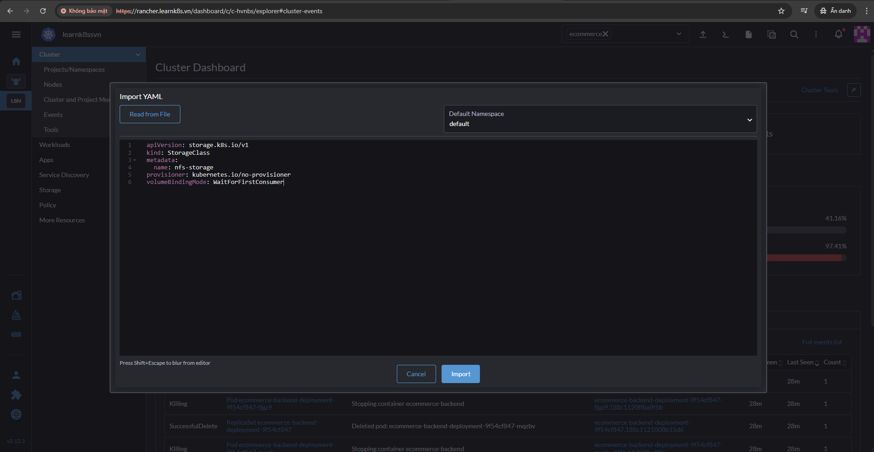
- Khong can chi ro namespace vi no la tai nguyen tren toan cum
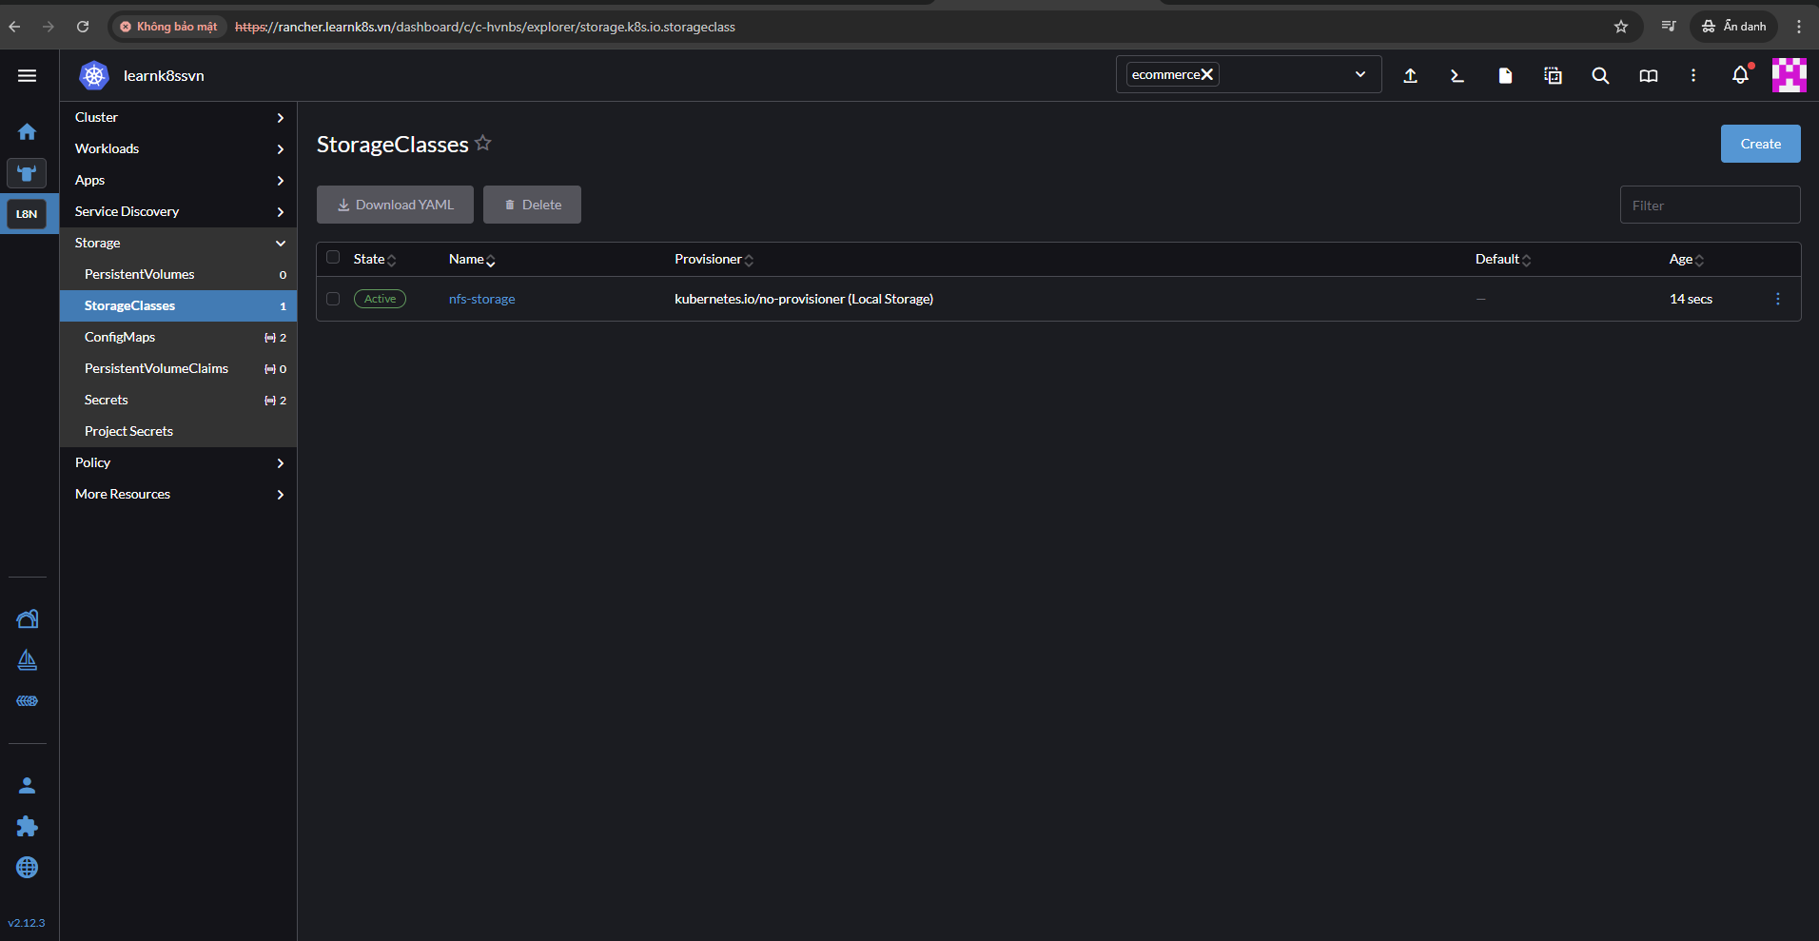
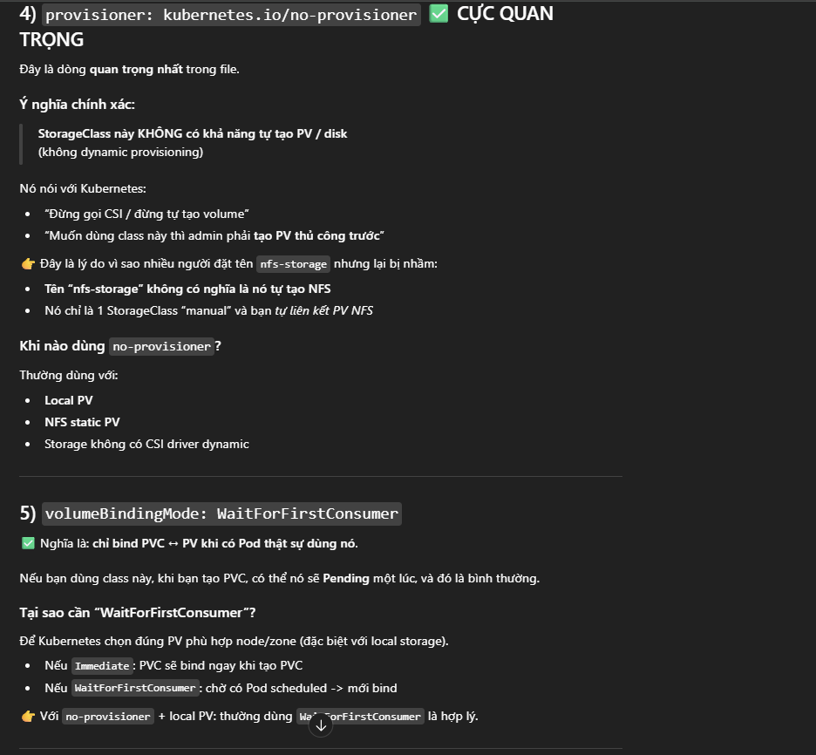
=> Khi khoi tao xong vao trong storageclas se thay

Lesson 34: PV & PVC Kubernetes
- Persistent Volume (PV) là mot doi tuong trong k8s de cung cap kha nang luu tru ben vung, PV co the luu tru cac nguon khac nhau nhu EPS, NFS,…
- PV la mot phan cu the trong kho nhu la mot tu de chua banh ma tiem san sang de luu tru, se co tu nho, tu lon dua theo kich thuoc. La 1 tai nguyen de khai bao mot vung chua cho cum k8s => se khoi tao 1 PV khai bao voi 10 GB bo nho => danh ra 1 vung luu tru rieng voi 10 GB bo nho => don gian chi la 1 volume nhu vay thoi.
- Persistent Volume Claim (PVC) la 1 yeu cau tu nguoi dung de su dung 1 luong luu tru cu the, cho phep nguoi dung yeu cau dung luong luu tru va che do truy cap. PVC trong tiem banh se la cach nhan su yeu cau, vi du muon 1 cai tu e nguyen lieu 10 chiec banh, chinh xac la chiec banh cung nhu la nguyen lieu phai de vua. PVC la 1 yeu cau su dung tai nguyen dua tren PV chung ta da tao. Vi du khai bao 1 PV voi 10 GB, tao 1 PVC yeu cau 5 Gb, tim 1 PV dap ung yeu cau do.
* Chu y:
- Types of Persistent Volumes
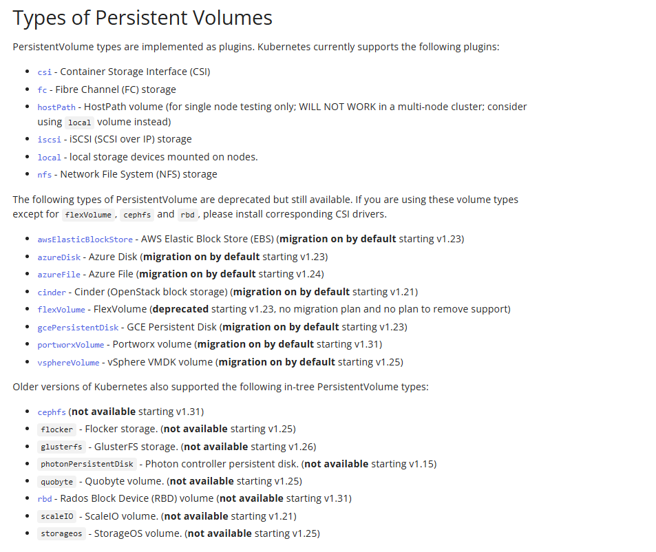
- hostPath => luu tru truc tiep tren server cai dat k8s. Vi du du an co pod chay tren k8s-master-1 => du lieu duoc luu tren k8s-master-1, neu pod bi loi vao replicaset tao lai o tren k8s-master-2, du lieu dang luu tren server k8s-master-1 thi k8s-master-2 se khong co => se khong duoc su dung ben vung trong thuc te => su dung trong moi truong test.
- Access Modes => su dung ReadWriteMany de quan he 1 -n, 1 mount point (thu muc ben ngoai) co the doc duoc nhieu pod trong cum k8s.
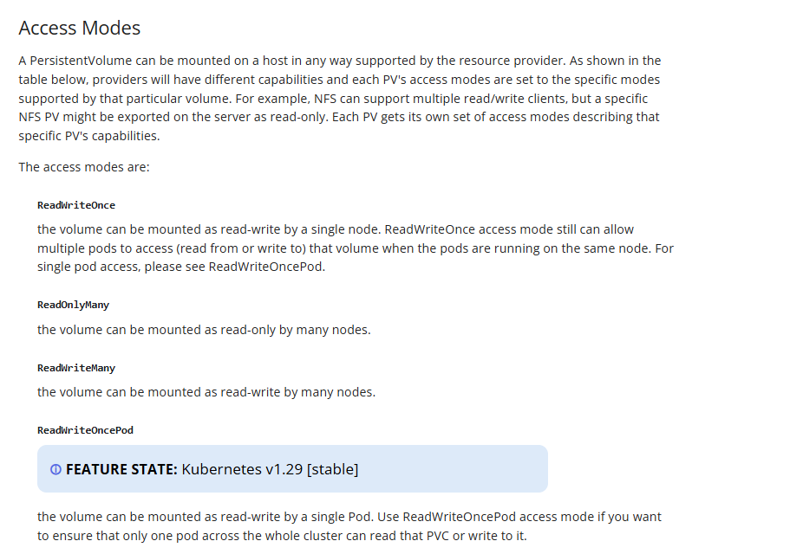
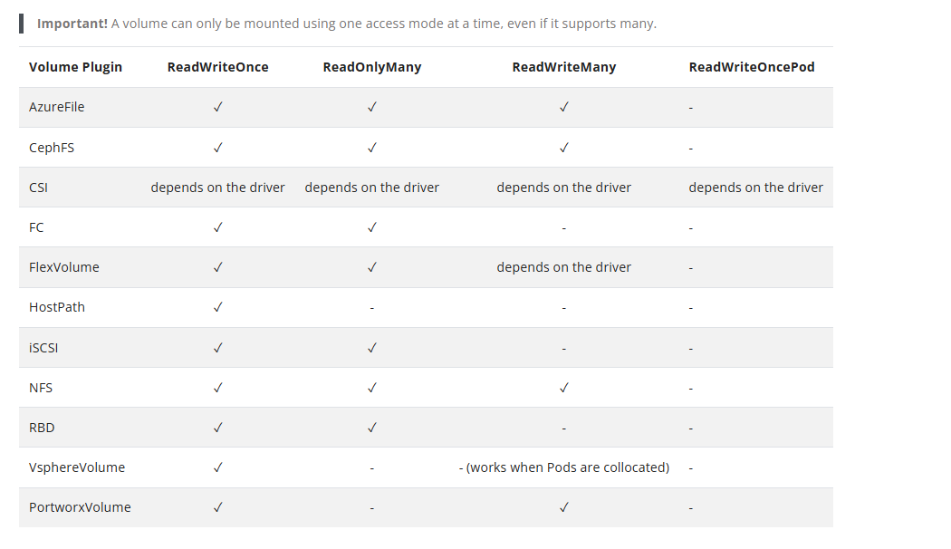
- Reclaim Policy => khi PVC khong can can thiet va xoa di thi du lieu trong PV se nhu the nao, nguyen lieu trong banh khong de trong tu nua thi se lam gi
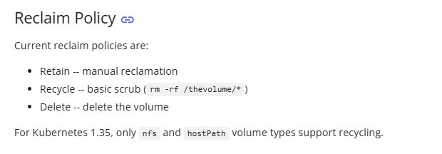
- De su dung duoc NFS thi se phai su dung NFS Server
- root@database-server:~# apt install nfs-server
- root@database-server:~# mkdir /data
- root@database-server:~# chmod -R 777 /data
- root@database-server:~# vi /etc/exports
- 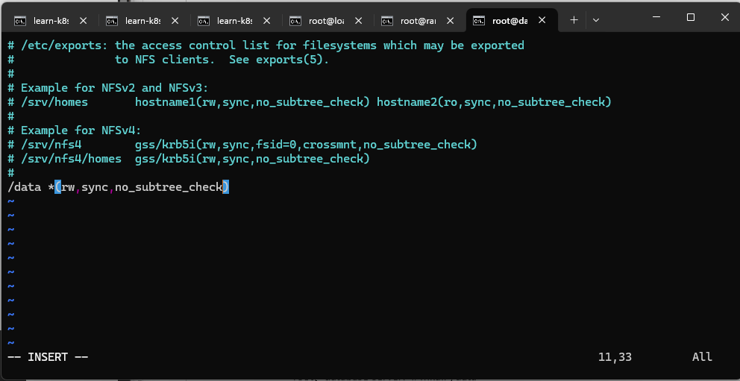
- root@database-server:~# exportfs -rav
- root@database-server:~# systemctl restart nfs-kernel-server

